261 School Ave Suite 100
Excelsior, MN 55331
p. 651-447-8898 e. mnmvmnt@gmail.com
www.minnesota-movement.com

Patient/Client Intake Form
Welcome to our office! Thank you for taking a moment to fill in our Intake Form. Please, fill this out completely and to the best of your knowledge. Let our staff know if you have any questions. When complete, return it to our office with the bottom authorization checked and appropriate signatures filled in.

Demographic Information

Personal Information
First Name: _______________ Middle Initial: ____ Last Name: _________________
Gender: □ Male □ Female Date of Birth: __________ Height: ____ Weight: ____
Marital Status: ______________ Spouse/Partner’s Name: ____________________
# of Children: _________
Emergency Contact: _____________________________
Relationship: _____________________________
Phone: ____________________________

Contact Information
Email: ___________________________________________________________
(We will not share your email with any third party. We will only use your email to contact you in relation to your care with our practice, which includes being subscribed to our MailChimp Email list.)
Home Phone: _______________ Cell: _______________ Work:________________
Address Line 1: _______________________________________________________
City: _____________________ State: ___________ Zip/Postal Code:___________

Current Complaints:
Symptom Symbols to use with marking on body images:
Aching = a Burning = b Numbness = n Sharp = s
Stiffness = f Tingling = g Weakness = w
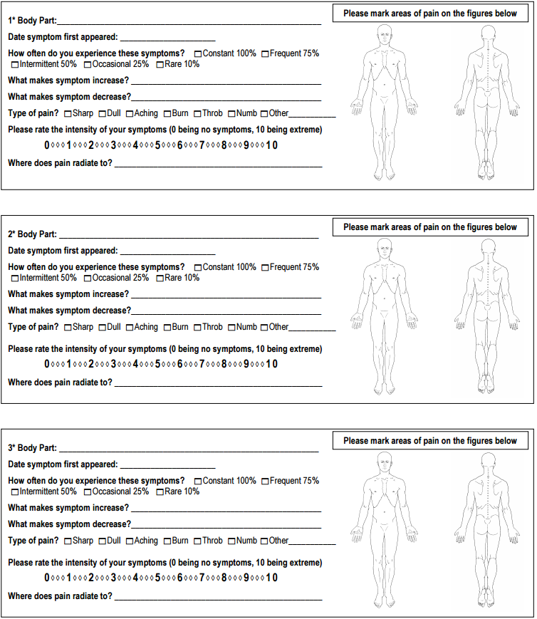
Where/how did the injury/injuries occur?:
□ Automobile □ Work □ 3rd Party Premises □Home □ Other
Date of injury/onset: ____________________________
Please, briefly describe how the injury/pain/discomfort originated:
________________________________________________________________________________________________________________________________________________________________________________________________________________________________.

Does this condition interfere with any of your daily activities or routines?:
□ NO □YES

Have you missed any work due to this injury?:
□ NO □ YES
If yes:
Unable to work from date: _____________
Day you have or will return to work: ________________

Is the pain/discomfort worse at certain times of the day?:
□ NO □ YES
If yes, explain:
_____________________________________________________________________________________________________________________________________________________.

Does the weather affect your pain/discomfort?:
□ NO □ YES
If yes, explain:
_______________________________________________________________________________________________________________________________________.

Have you received other professional treatment for this condition?
□NO □YES
If yes, explain:
_____________________________________________________________________________________________________________________________________________________.
Please list other practitioners seen for this injury/condition:
_____________________________________________________________________________________________________________________________________________________.

Have you ever had x-rays taken for this condition?
□NO □YES
If yes, where? _______________________________________________________________.

Have you ever had this same condition?
□NO □YES
If yes, when? ______________________
Have you had previous chiropractic care?
□NO □YES
Are you pregnant, or have you had any signs of pregnancy?
□NO □YES
Are you planning to get pregnant in the next 12 months?
□NO □YES

Please list any current medications/vitamins/supplements/herbs:
_____________________________________________________________________________________________________________________________________________________.
Please list any previous injuries, illnesses, hospitalizations or surgeries (major or minor):
________________________________________________________________________________________________________________________________________________________________________________________________________________________________.
Family History:
Please list any genetic or hereditary issues/diseases/complications/conditions that your immediate family (Mom, Dad, Brothers, Sisters, Spouse, Children) currently has:
________________________________________________________________________________________________________________________________________________________________________________________________________________________________. Describe your use of Caffeine, Tobacco and Alcohol:
Caffeine __________________ Tobacco/Cigarettes ____________________
Alcohol ___________________ Other Drugs __________________________
Goals:
Please answer the following questions on a scale of 0 to 10 with 0 being the worst and 10 being the best.
How would you rate your overall health?
(LOW) 0 --- 1 --- 2 --- 3 --- 4 --- 5 --- 6 --- 7 --- 8 --- 9 --- 10 (HIGH)
How would you rate your current state of nutrition?
(LOW) 0 --- 1 --- 2 --- 3 --- 4 --- 5 --- 6 --- 7 --- 8 --- 9 --- 10 (HIGH)
How would you rate your current activity level?
(LOW) 0 --- 1 --- 2 --- 3 --- 4 --- 5 --- 6 --- 7 --- 8 --- 9 --- 10 (HIGH)
How would you rate your current physical fitness level?
(LOW) 0 --- 1 --- 2 --- 3 --- 4 --- 5 --- 6 --- 7 --- 8 --- 9 --- 10 (HIGH)
How would you rate your overall mental health?
(LOW) 0 --- 1 --- 2 --- 3 --- 4 --- 5 --- 6 --- 7 --- 8 --- 9 --- 10 (HIGH)
How would you rate your current stress level (work/family/recreational)?
(LOW) 0 --- 1 --- 2 --- 3 --- 4 --- 5 --- 6 --- 7 --- 8 --- 9 --- 10 (HIGH)
Please list your goals of any/all treatment rendered here at Minnesota Movement below:
________________________________________________________________________________________________________________________________________________________________________________________________________________________________.

Authorization Statement
I certify that I’m the patient, client, or legal guardian listed in the intake. I have read/understand the included information and certify it to be true and accurate to the best of my knowledge. I consent to the collection and use of the above information to this office of chiropractic and/or massage therapy. I authorize this office and its staff to examine and treat my condition as the doctors or therapist see fit. I understand and agree that all services rendered to be will be charged to me, and I’m responsible for timely payment of such services. I understand and agree that health/accident insurance policies are an arrangement between an insurance carrier and myself. I understand that fees for professional services will be come immediately due upon suspension or termination of my care or treatment.
I understand that the massage treatment I receive within this office is provided for the basic purpose of relaxation and relief of muscular tension. If I experience any pain or discomfort during any treatment session I will immediately inform the doctor or therapist/staff. I understand that, if I am seeking massage therapy here at Minnesota Movement, a massage should not be construed as a substitute for a medical examination, diagnosis, or treatment that I should seek a physician or other qualified medical professional for. Only the doctor(s) or other qualified medical professional here at Minnesota Movement is capable of diagnosing and treating a diagnosis with spinal/skeletal adjustments.
I agree to keep the office of Minnesota Movement updated as to any changes in my medical profile and understand that there shall be no liability on the office of Minnesota Movement’s part should I fail to do so.
Release of Records
I understand and give consent for Minnesota Movement to release any of my medical records recorded in this office with other health or medical providers that I am currently seeing either within this office such as Dr. Reid Nelles or Dr. Claire Jessen or external providers. Any request for records by an external provider will elicit a notification from Minnesota Movement to me for such request. I hereby authorize the doctor to release all information necessary to any insurance company, attorney, or adjuster for the purpose of claim reimbursement of charges incurred by me. I grant the use of my signed statement of authorization with my signature for required insurance submissions.
Cancellation Policy
There is a full visit fee for missed appointments without a 24 hour notice. 48 hour advance cancellation is preferred and 24 hour advance cancellation is required.
If you are unable to keep your appointment, please notify us as soon as possible. Our answering machine is on 24 hours a day. Because we do not double-book appointments, when you break your appointment, we are not able to fill the empty spot (unless, at least 24 hour notice is given). As time and space is limited, someone else may not be able to be seen by us. We value your time, please value ours as well. If we are not contacted within 24 hours prior to appointment, you will be charged a missed appointment fee on that day. We will require a credit card that we will keep on file for that purpose only.
We do not double book appointments. Those who are late will have a shorter session so the next patient won’t have to wait.
□ I agree with this statement of authorization, release of records, and the cancellation policy.
Name of patient: ___________________________
Patient/Guardian Signature: ______________________________
Date: __________________________________

